1: Create an account on Zopim.com

2: Add the source code here to the site.master head

<!--Start of Zopim Live Chat Script-->

<script type="text/javascript">

window.$zopim||(function(d,s){var z=$zopim=function(c){z._.push(c)},$=z.s=

d.createElement(s),e=d.getElementsByTagName(s)[0];z.set=function(o){z.set.

_.push(o)};z._=[];z.set._=[];$.async=!0;$.setAttribute("charset","utf-8");

$.src="//v2.zopim.com/?2srgjUGVaum0iKzECFzHSTXjsWYJUVGp";z.t=+new Date;$.

type="text/javascript";e.parentNode.insertBefore($,e)})(document,"script");

</script>

<!--End of Zopim Live Chat Script-->

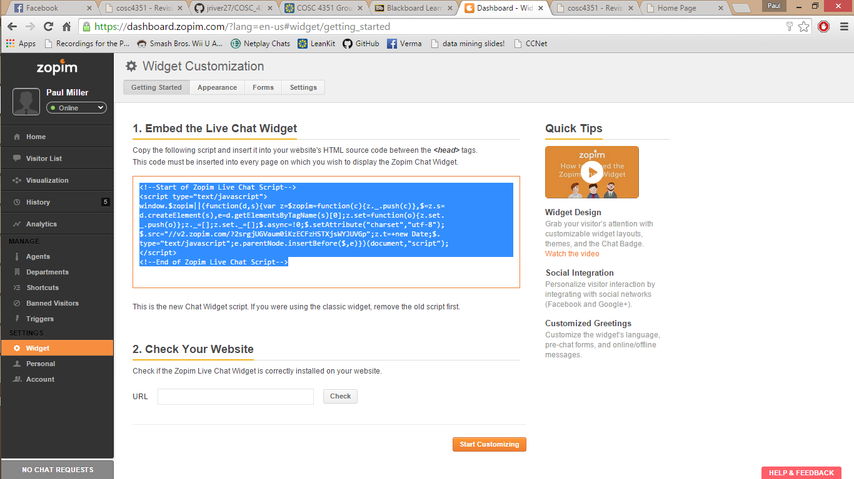

User:

The User will have a chance to chat with an agent if one is available. In the bottom right corner of the website, there will be a box that says “ask us anything”. By typing a message in the appropriate box, the user can communicate directly to an agent standing by, or if no agent is available, an email is sent to Zopim and agents are notified that a message is waiting.

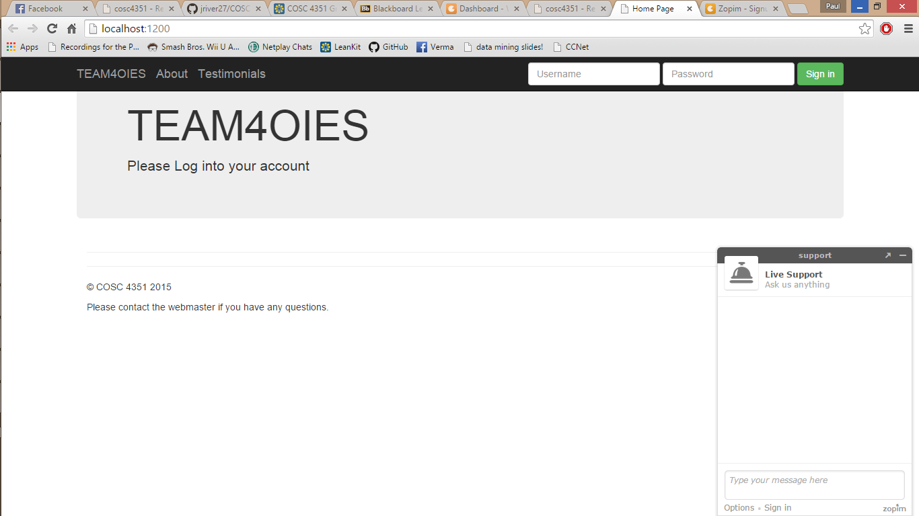

Agent:

An agent has a dashboard on Zopim that has lot of features including a chat history log, a list of agents, and a visitor list. When a user types a message to an agent, the agent receives a notification in the Zopim dashboard and can immediately type to the visitor.

When an account is created on Zopim, there is a free trial for 15 days after the account is created. After 15 days, the users can chose to pay for the more features. Without the paid version, the chat only includes these features:

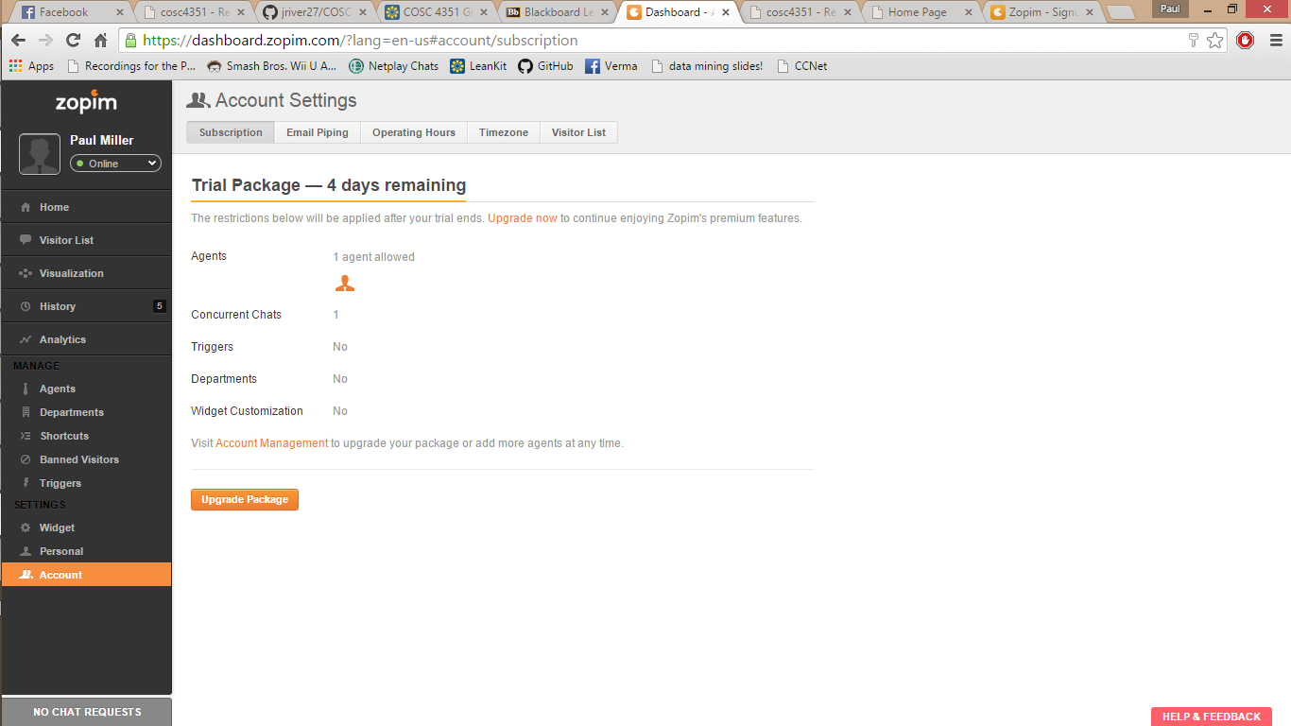

If this system were to be used, a premium account would be needed but for the prototype, we can use the free version.